# What is new in .NET 3.5?

## Add-ins and Extensibility

The .NET Framework programming model for add-ins supports the development of a communication pipeline that enables the hosting of add-ins under a variety of adaptable scenarios.

## Add-in Model

The add-in model consists of a series of segments that make up the add-in pipeline (also known as the communication pipeline), that is responsible for all communication between the add-in and the host. The pipeline is a symmetrical communication model of segments that exchange data between an add-in and its host. Developing these segments between the host and the add-in provides the required layers of abstraction that support versioning and isolation of the add-in.

The model achieves this by constructing a communication pipeline between the host and the add-in

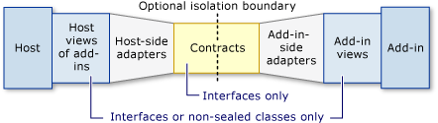

### Features of the add-in model:

* Independent Versioning
* Discovery and Activation
* Isolation Levels and External Processes
* Lifetime Management
* Sandboxing
* UI Composition

Add-in pipeline with types

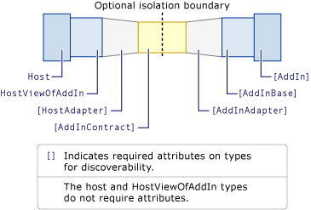

The contract is the only assembly that is loaded in both the host and add-in application domains.

Activation path from the add-in to the host

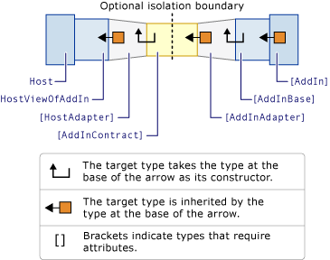

## Common Language Runtime

### Collections

[HashSet<(Of <(T>)>)](http://msdn.microsoft.com/en-us/library/bb359438.aspx) provides high performance set operations to the .NET Framework

### Diagnostics

The [EventSchemaTraceListener](http://msdn.microsoft.com/en-us/library/system.diagnostics.eventschematracelistener.aspx) class provides tracing of end-to-end, schema-compliant events.

### I/O and Pipes

The .NET Framework provides access to two types of pipes: anonymous pipes and named pipes. For more information about pipes

### Garbage Collection

The [GCSettings](http://msdn.microsoft.com/en-us/library/system.runtime.gcsettings.aspx) class has a new [LatencyMode](http://msdn.microsoft.com/en-us/library/system.runtime.gcsettings.latencymode.aspx) property that you can use to adjust the time that the garbage collector intrudes in your application

### Reflection and Reflection Emit in Partial Trust

Assemblies that run with partial trust can now emit code and execute it.

### Threading

#### Better Reader/Writer Lock

The new [ReaderWriterLockSlim](http://msdn.microsoft.com/en-us/library/system.threading.readerwriterlockslim.aspx) class provides performance that is significantly better than [ReaderWriterLock](http://msdn.microsoft.com/en-us/library/system.threading.readerwriterlock.aspx), and comparable with the lock statement (SyncLock in Visual Basic).

#### ThreadPool Performance Enhancements

Throughput for the dispatch of work items and I/O tasks in the managed thread pool is significantly improved. Dispatch is now handled in managed code, without transitions to unmanaged code and with fewer locks.

### Time Zone Improvements

Two new types, [DateTimeOffset](http://msdn.microsoft.com/en-us/library/system.datetimeoffset.aspx) and [TimeZoneInfo](http://msdn.microsoft.com/en-us/library/system.timezoneinfo.aspx), improve support for time zones and make it easier to develop applications that work with dates and times in different time zones.

### Cryptography

#### Suite B Support

The .NET Framework 3.5 supports the Suite B set of cryptographic algorithms published by the National Security Agency (NSA).

The following algorithms are included:

* Advanced Encryption Standard (AES) with key sizes of 128 and 256 bits for encryption.
* Secure Hash Algorithm (SHA-256 and SHA-384) for hashing.
* Elliptic Curve Digital Signature Algorithm (ECDSA) using curves of 256-bit and 384-bit prime moduli for signing. This algorithm is provided by the [ECDsaCng](http://msdn.microsoft.com/en-us/library/system.security.cryptography.ecdsacng.aspx) class. It allows you to sign with a private key and verify with a public key.
* Elliptic Curve Diffie-Hellman (ECDH) using curves of 256 and 384-bit prime moduli for key exchange/secret agreement. This algorithm is provided by the [ECDiffieHellmanCng](http://msdn.microsoft.com/en-us/library/system.security.cryptography.ecdiffiehellmancng.aspx) class.

### Networking

Peer-to-Peer Networking

Socket performance improvements.

### Windows Forms

#### Authentication, Roles, and Settings Services

Client application services are new in the .NET Framework 3.5 and enable Windows-based applications (including Windows Forms and Windows Presentation Foundation applications) to easily access the ASP.NET login, roles, and profile services

### LINQ

### Expression Trees

Expression trees are new in the .NET Framework 3.5, and provide a way to represent language-level code in the form of data.The [System.Linq.Expressions](http://msdn.microsoft.com/en-us/library/system.linq.expressions.aspx) namespace contains the types that are the building blocks of expression trees. These types can be used to represent different types of code expressions, for example a method call or an equality comparison.

Expression trees are used extensively in LINQ queries that target remote data sources such as a SQL database. These queries are represented as expression trees, and this representation enables query providers to examine them and translate them into a domain-specific query language.

## What is new in WPF 3.5

### Visual and Nonvisual Add-Ins in WPF

Similar to the Add-ins support above.

### 3-D Graphics

The following new features have been added to the 3-D object model.

#### Input, Focus, and Eventing Support in 3-D

The 3-D object model now supports [UIElement](http://msdn.microsoft.com/en-us/library/system.windows.uielement.aspx) concepts such as input, focus, and events. The new classes that provide these services are [UIElement3D](http://msdn.microsoft.com/en-us/library/system.windows.uielement3d.aspx) and its derived classes [ContainerUIElement3D](http://msdn.microsoft.com/en-us/library/system.windows.media.media3d.containeruielement3d.aspx) and [ModelUIElement3D](http://msdn.microsoft.com/en-us/library/system.windows.media.media3d.modeluielement3d.aspx). For examples, see [UIElement3D Sphere Sample](http://msdn.microsoft.com/en-us/library/bb913899.aspx) and [Handling Events in 3-D Sample](http://msdn.microsoft.com/en-us/library/bb913901.aspx).

#### Interactive 2-D Content on 3-D

The new class [Viewport2DVisual3D](http://msdn.microsoft.com/en-us/library/system.windows.media.media3d.viewport2dvisual3d.aspx) provides the support for placing interactive 2-D content onto a 3-D object. For an example, see [Interactive 2-D on 3-D Sample](http://msdn.microsoft.com/en-us/library/bb913896.aspx).

#### New Transformation Services

The new classes [GeneralTransform3D](http://msdn.microsoft.com/en-us/library/system.windows.media.media3d.generaltransform3d.aspx), [GeneralTransform2DTo3D](http://msdn.microsoft.com/en-us/library/system.windows.media.media3d.generaltransform2dto3d.aspx), and [GeneralTransform3DTo2D](http://msdn.microsoft.com/en-us/library/system.windows.media.media3d.generaltransform3dto2d.aspx) enable transformations between [Visual3D](http://msdn.microsoft.com/en-us/library/system.windows.media.media3d.visual3d.aspx) objects and from 2-D to 3-D and vice versa.